Laser Show System

User Manual

Four Heads Laser Light

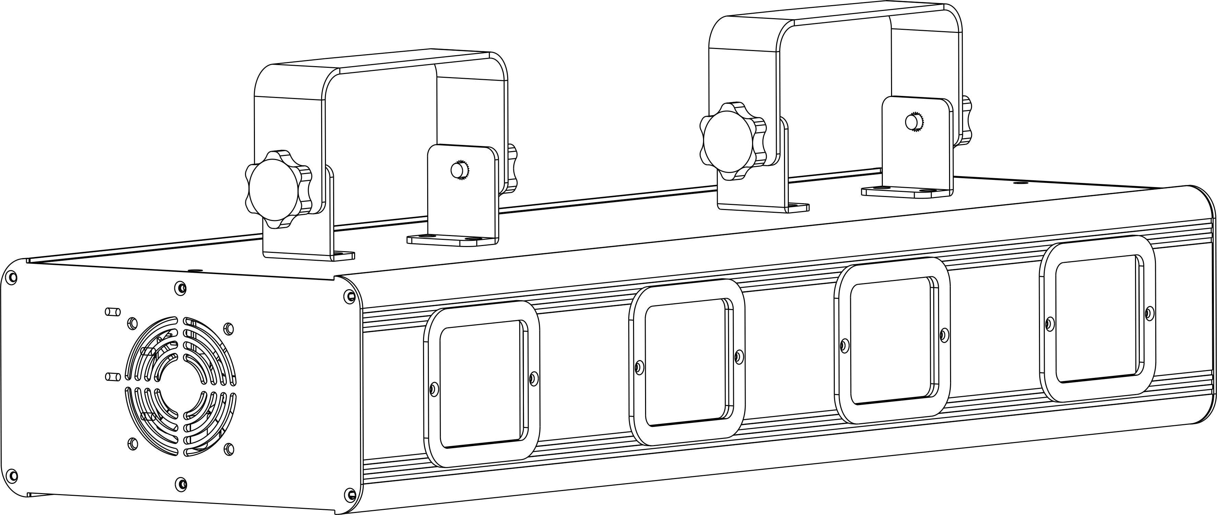

Please read this manual carefully before use!
Introduction
Thank you for purchasing this product. To optimize the performance of this product,prior to use,please read these operating instructions carefully to familiarise yourself with the basic operation of this unit.Please keep the manual in safe price for future reference.

This unit has been tested at our factory before being shipped to you, there is no assembly required.

Once after received this product , please take and put carefully. And check cautiously that whether the product was damaged or not during the transportation.

Checking Parts
Please check if the following parts are included:
1 x Laser light
1 x Power cable
1 x User manual
1 x Handle

Danger Laser Radiation!

Avoid direct eye exposure!
Laser radiation can cause eye damage or skin damage
All protective measures for a safe operation of this laser must be applied.

Installation

1. Please check the voltage whether is the same with the one showed on the equipment or not.

2. It must ask for the technical person and set the light safety when installation. And let the light beam at the suitable angle.

3. When install this equipment please make sure there's no flammable surfaces (decorated things, etc) within at least 2.5M and maintain minimum distance of 0.5M from the equipment to the walls.

4. Please make sure that there's no other equipment or decorating materials obstructed the exhaust fan and the vent-pipe.

5. Products should be install immobility.
6. In case of safety, it's very important that to connect the earth with line.

Attention

1.Please do not open the bottom cover yourself without permission.Operate it accord the user manual. Call the technician when the machine breaks down.

2.Please do not see the laser beam directly to avoid any damage.

3.Before connect or disconnect the power, please adjust the luminance of the laser diode to the least to avoid any damage to the laser diode.

4.This unit should be keep dry, do not use in the rain and dusty environment. It can be use in the outdoor with the water-proof cover protector.

5. Set the light immobility and try to avoid strong shake or hit.

6.Prevent dust into the equipment to avoid problems.

7.Please keep that there's no other equipment or decorating materials obstructed the exhaust fan and the vent-pipe when the equipment was working.

8.Before connect power, check the plug is immobility or not, power line should be connect well.

9.Please do not open or close the equipment frequently that's to avoid any affect to the life span of the laser diode, and try the best to avoid the long time working.

10.Due to the characteristic of the laser diode, after four hours working, it should be close at least 25 minutes until the laser diode cooling then work again.

11.Don't touch the light or draw the power line when your hand was wet. And do not pull the electronic power line.

12.Maintain the distance at least 3M above from the equipment to the object.

13.This equipment does not have any parts can repair for the users, please do not open the equipment.

14.When the laser diode became dim or damaged please contact the dealer timely.

15.When you want to retransfer the products,you'd better use the original package to shockproof.

Display Menu Description

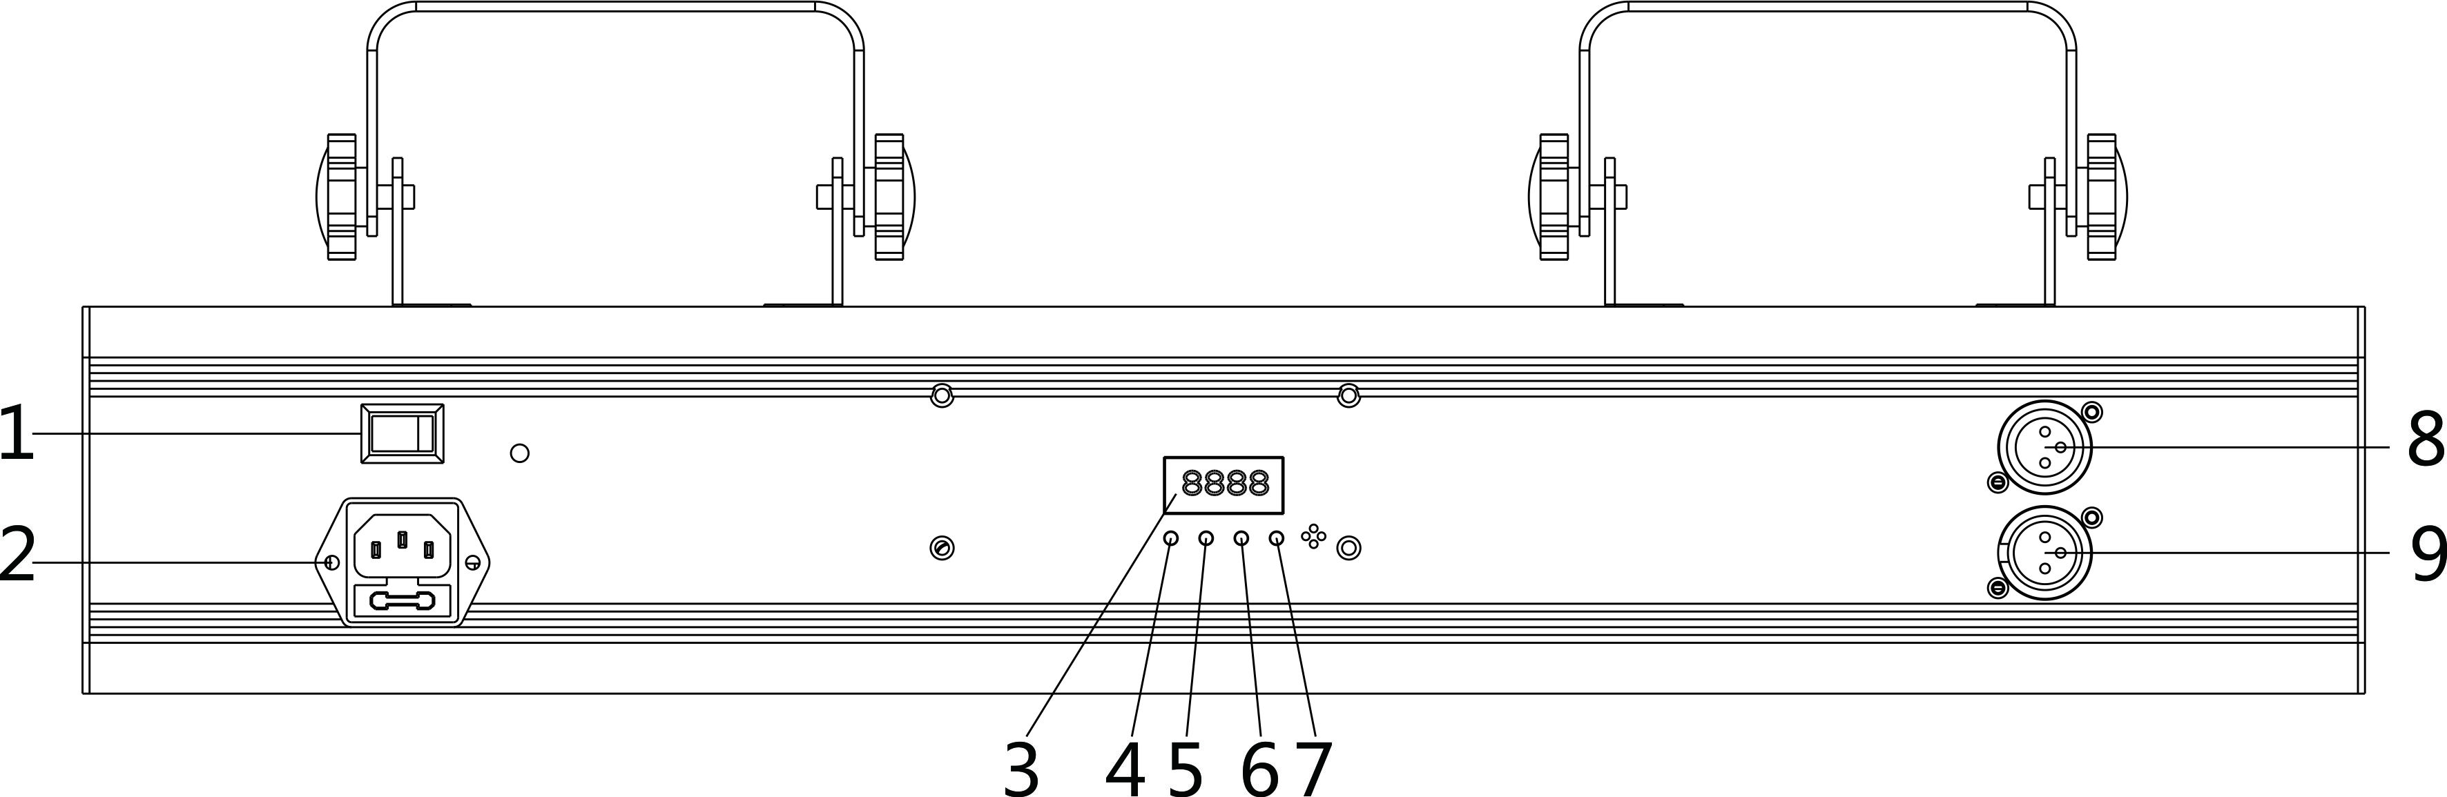

- Switch 2.Power in 3.Display board 4.MENU 5.UP 6.DOWN 7.ENTER 8.DMX in 9.DMX out
 | MENU | UP/DOWN | Default | Function
1 | Addr | 1-512 | 1 | Setting address code/DMX/Slave
2 | AUTO | AUT.1---AUT.9 | 8 | Auto mode,auto speed adjustment
3 | SOUND | SOU.1---SOU.9 | 8 | Sound mode，Sound sensitivity adjustment
4 | TEST |  |  | Square test pattern

Set DMX Address
- Press <Menu>to enter edit menu page
- Tap the <Up/Down>button and press <Enter> to enter<Addr>
- Tap the <Up/Down>button to set address code “1~512”
- Press ENTER to confirm and exit
Auto Mode
- Press <Menu>to enter edit menu page
- Tap the <Up/Down>button and press <Enter> to enter<Auto>
- Tap the <Up/Down>button to choose“AUT.1---AUT.9”
- Press ENTER to confirm and exit

Sound mode
- Press <Menu>to enter edit menu page
- Tap the <Up/Down>button and press <Enter> to enter<Sound>
- Tap the <Up/Down>button to choose“AUT.1---AUT.9”
- Press ENTER to confirm and exit

Whole light test function
1.Press <Menu>to enter edit menu page
2.Tap the <Up/Down>button and press <Enter> to enter<TEST>

Channel Instruction

CH1 | Mode control | 0-9 | DMX
CH1 | Mode control | 10-249 | AUTO
CH1 | Mode control | 250-255 | SOUND
CH2 | Laser color control | 0-9 | Laser off
CH2 | Laser color control | 10-127 | Choose laser fixed color
CH2 | Laser color control | 128-255 | Laser color water chase,speed from slow to fast
CH3 | Choose laser pattern | 0-255 | Choose laser pattern
CH4 | Choose laser pattern’s size | 0-63 | Choose laser pattern size
CH4 | Choose laser pattern’s size | 64-127 | Pattern size from small to big and choose speed
CH4 | Choose laser pattern’s size | 128-191 | Pattern size from big to small and choose speed
CH4 | Choose laser pattern’s size | 192-255 | Zoom in and out and choose speed
CH5 | Laser pattern rotation | 0-127 | Rotation angle option
CH5 | Laser pattern rotation | 128-191 | Clockwise rotation speed option
CH5 | Laser pattern rotation | 192-255 | Counter- clockwise rotation speed option
CH6 | Flip horizontal site selection | 0-127 | Flip horizontal site selection
CH6 | Flip horizontal site selection | 128-255 | Flip horizontal speed choice
CH7 | Vertical roll site selection | 0-127 | Vertical roll site selection
CH7 | Vertical roll site selection | 128-255 | Vertical roll speed choice
CH8 | Horizontal position choice | 0-127 | Horizontal position choice
CH8 | Horizontal position choice | 128-255 | Horizontal move speed selection
CH9 | Vertical position choice | 0-127 | Vertical position choice
CH9 | Vertical position choice | 128-255 | Vertical move speed selection
CH10 | Display mode | 0-127 | Normal display
CH10 | Display mode | 128-255 | Dot display
CH11 | Scan speed | 0-255 | Scan speed from slow to fast

Maintenance

Maintenance should be performed every 15-day period, by using a sponge which is dipped with alcohol, rather than wet cloth or other chemical liquid, to clean the mirror.

Always disconnect from the mains when the device is not in use or before cleaning it.

Warning
Power must be disconnected before maintenance or repair. Do not look at the light source directly

To prevent or reduce the risk of electrical shock or fire.do not expose this unit to high temperature/rain or moisture.

Note

Don't separate laser machine from laser power and repair them by yourself , otherwise no good repair service will be supplied.

Technical Specifications
1.Power Supply: AC 100-240V
2.Rated power: 45W
3.Working mode: Sound Active/ Auto-play/DMX512/Master-Slave
4.Control signal: DMX512 signal
5.DMX channels:11

6.Operating temperature: -1º--35º

7.Storage temperature: -10º--60º

8.Warm-Up time :<15 min

9.Modulation: TTL

Declaration
This device has left our premises in absolutely perfect condition. In order to maintain this condition and to ensure a safe operation, it is absolutely necessary for the user to follow the safety instructions and warning notes written in this user manual.

We cannot be made liable for damages caused by incorrect installations and unskilled operation!

Warranty Card
This product is made of high-brightness transistor. We will provide 1 year warranty under the condition that user has operated the light normally and lifetime service. We won't provide warranty if the damage is caused by artificial or force majeure event. Cost of fittings should be charged by user if product need maintenance after 1 year .Please cut this warranty card and shipped it along with the product to our factory when applying for warranty.
Product： Purchasing date： Code of invoice：
Warranty date: From To
User’s name： Add：
Company： Tel：

